**Leader Overview**



**Volume Overview**

**Get Going**

*The gift of the Holy Spirit was sent so that we might have power—power to go and make disciples. Some go to the farthest corners of the globe. Some only cross the street in front of their house. Still, God’s people always go. They go to work, school, grocery stores, kids’ soccer games, and family reunions. And wherever they go, they take their witness of Jesus with them. True believers live going and carrying out His mission.*

**Session Overview**

**Go Forth**

*In this* **Live** *session, preschoolers will discover that Jesus calls all of us to play an important role in His mission. Sometimes we get to do that with others. This Bible story of Jesus sending out disciples in pairs also shows kids that we can trust Jesus to provide for us as we fulfill the role He has called us to.*

**Bible Lesson**

The Disciples Choose to Go

[Luke 10:1–20](https://ref.ly/logosref/Bible.Lk10.1-20)

**Faith Fact**

I have a role to play.

**Faith Verse**

[John 20:21](https://ref.ly/logosref/Bible.Jn20.21) (NLT)

[Jesus] said, “Peace be with you. As the Father has sent me, so I am sending you.”

**Preparing for the Session**

**Leader Preparation Time: 20–25 Minutes**

|  |
| --- |
| ***You Will Need***  ***Preservice Activities***  *• Toys*  *• Suitcase*  *• Foods to make trail mix (pretzels, raisins, chocolate chips or M&Ms, goldfish crackers, sunflower seeds, cereal, etc.)*  *• Zipper sandwich bags, one per kid*  *• Bowls, paper or plastic, one per food item*  *• Spoons or tongs, one per food item*  ***Large Group***  *• Bible*  *• Worship songs (Song suggestions: “Do What You Wanna Do” Lyric Video by Elevation Church Kids; “I Know I Belong” Lyric Video by Saddleback Kids*  *• For groups not using a phone or tablet only, add:*  *• Projector or TV*  *• Laptop*  *•* ***Faith Fact Sound*** *video (bell ringing)*  *•* ***Faith Fact Slide***  *•* ***Faith Verse Slide*** *or* ***Video***  *•* ***Bible Lesson Video A***  *•* ***Bible Lesson Video B***  ***Small Group***  *• Blindfold or bandana*  *• Something that makes noise (bell, set of keys, rubber duck, etc.)*  *•* ***Small Group Activity Page****, one per kid*  *• Crayons or markers*  *• Floor safe tape (painter’s tape or masking tape)*  *•* ***Small Group Hands-On Learning Page****, one per group*  *To access session content and videos from a computer, visit:* [***BibleEngagementProject.com/downloads***](https://bibleengagementproject.com/downloads) |
| ***Getting Ready***  ***Preservice Activities***  *• Set out toys and snacks.*  *• Place each ingredient of the trail mix in a separate bowl with a spoon or tongs.*  ***Large Group***  *• Download videos and slides if needed.*  *• Select worship song(s) and have them ready to play.*  ***Small Group***  *• Print copies of the* ***Small Group Activity Page****, one per kid.*  *• Make a path on the floor by taping lines that kids will walk along (zigzag, dashes for hopping, etc.).*  *• Make the path about 8–10 feet long.*  *• For larger groups, make more than one path for kids to follow to allow more than one group of kids to travel at a time.*  *• Print the* ***Small Group Hands-On Learning Page****, one per group*  ***First time leading* Live *for Preschool? Check out the*** [**Facilitator Guide**](https://0b769b0ed3569ef9d18b-f88d8272f61086866d50d048b43ef630.ssl.cf2.rackcdn.com/sites/biblengagementproject/Listen_Facilitator_Guide.pdf)**.** |

**Preservice Activities**

*See what’s needed at the beginning of the session.*

**Bible Story Warm-Up**

• *When kids arrive, have them sit down in a circle with you.*

Hey, friends! I’ve got a question for you. *(Point to the suitcase.)* Has anyone ever seen one of these? *(Allow responses.)* I was thinking you might have. When do we use a suitcase? *(Allow responses.)* I use one when I go on trips. It does a great job of helping me get my things to wherever I’m going.

Have you ever packed a suitcase to go somewhere?

What kind of things are normally in a suitcase?

Where would you like to travel with a suitcase?

In our Bible story today, we’ll learn about some people in the Bible who went on a trip. They didn’t pack a suitcase like this one. What I do know, though, is that this was a pretty important trip. Someone very special was sending them with a very special job to do. Can anyone guess who that very special person was? *(Allow responses.)* That’s right! It was Jesus.

It’s important to be ready to go wherever Jesus might want us to go. That doesn’t mean we need to carry a suitcase around with us all the time. But, we do need to listen to what Jesus might be telling us to do. This will be a fun day learning more about this together from the Bible.

**Snack**

**Trail Mix Fun**

• *Be aware of and plan around any food allergies or sensitivities your preschoolers may have.*

I love eating snacks on trips! How about you? *(Group response)* A lot of people like to eat something called trail mix. It’s called a trail mix because people take it with them when they are hiking or going on a journey. Trail mix has a lot of different small foods in it to give you energy, such as nuts and raisins. There are all different kinds of trail mixes. Some are sweet, some are salty, and some are even spicy! Today for our snack, you get to make your own trail mix.

• *Give each kid a zipper bag.*

• *Allow kids to create their own trail mix for snack time.*

Was it fun to make your own snack? *(Group response)* What was your favorite thing that you put in your trail mix? *(Allow responses.)* It can be fun to follow the instructions to make something good to eat. Today, we’ll learn about some special instructions that Jesus gave to some of His friends about what to do.

**Free Play**

*Any extra time can be spent playing with toys.*

**Transition**

*A few minutes before service begins have kids make their way to the large group area and sit in their designated areas.*

**Large Group**

**25 Minutes**

*See what’s needed at the beginning of the session.*

**Introduction**

Hi, kids! I’m so glad to see all of you here today. It’s always a good day when we can come together and learn from God’s Word. *(Hold up the Bible.)* If you’re ready to have some fun, give me a big wave. *(Group response)*

Today, we’ll learn about a big group of people who received specific instructions from Someone special. This special Person loves us all very much and has a plan for our life. Who am I talking about? *(Allow responses.)* Jesus! Today, we’ll learn how Jesus told people they have a role to play in telling others about Him.

**Faith Fact**

Jesus has an important role for you and me to play. Our Faith Fact will help us remember that. **I have a role to play.**

• *Show the* ***Faith Fact Slide.***

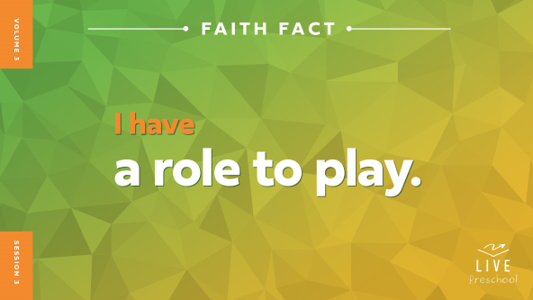

Let’s say our Faith Fact together so we remember it. First, let’s whisper it quietly like it’s a secret. **I have a role to play.** Great job! This time let’s shout it like we’re telling the whole world! **I have a role to play.**

**Bible Time**

What does it mean that each one of us has a role to play? *(Group response)* Jesus has a special plan for each of us. In order to play the role Jesus has for us, we need to know what to do. There’s a book that tells us those things. Who knows what important book I’m talking about? Shout it out! *(Group response) (Hold up the Bible.)* That’s right! It’s the Bible. We have a friend who loves to explore Bible stories with us. Let’s see what Lizzy is doing.

• *Play* ***Bible Lesson Video A.***

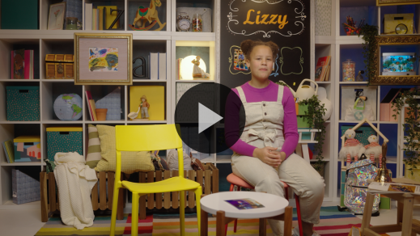

I’m glad Lizzy gave us a little time to think. Let’s worship now. Then, I’ll ask you what you think will happen next in our Bible story.

**Worship**

God is so good! He loves you and me more than we can even understand. Let’s show God how much we love Him through praise and worship.

**Praise**

Are you glad we can learn more about Jesus in the Bible? Wave your hands up high. *(Group response)*

Who wants to thank Jesus for giving us a role to play? Touch your toes down low. *(Group response)*

Who wants to say yes to Jesus’ role for you? Give your highest jump. *(Group response)*

**Sing**

Are you ready to use your singing voices to worship God? Let’s warm them up. Follow me. *(High voice: la-la-la-la) (Group response) (Low voice: la-la-la-la) (Group response)* Beautiful! Now, we’re ready to sing.

• *Lead the kids in singing one or two songs. See song suggestions at the beginning of the session.*

**Prayer**

Those things we sang about God are so true. It’s amazing to me that God loves to talk to us, and He loves it when we to talk to Him. Let’s bow our heads and pray.

|  |
| --- |
| *Dear God, thank You for who You are. You are loving and kind, and You want good things for us. Help us to feel Your love in a powerful way today. Help us to grow closer to You. Amen.* |

**Bible Time cont’d**

• *Start* ***Bible Lesson Video B*** *and pause on the image of the two choices.*

Oh! Lizzy will be back soon. We should figure out what we think happens next in our Bible story. Can you put on your thinking caps? *(Demonstrate.)* Did Jesus’ seventy-two disciples listen to His instructions? *(Point to “ear” graphic.)* Or did they ignore Jesus and try to preach on their own? *(Point to “ear crossed out” graphic.)*

If you think the disciples listened to Jesus, cup your hands around your ear like you’re listening *(demonstrate)*. If you think the disciples tried to go and preach without listening to Jesus’ instructions, cover your ears with your hands *(demonstrate)*. Ready? Choose your answer.

• *Pause while kids respond.*

Let’s find out if you’re right.

• *Play* ***Bible Lesson Video B.***

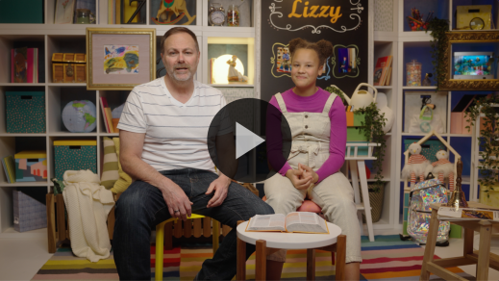

Wow, everything the disciples needed was taken care of! That shows me that we can trust Jesus with the things we need, too.

**Response Time**

*Play a worship song quietly.*

When Jesus tells us to play a role in showing others His love, He is so faithful to help us. Let’s respond to what we’ve learned today. First, touch your ears. Are your ears willing to listen to Jesus’ instructions for you? *(Group response)* Let’s bend down and touch our feet. Are your feet willing to go where Jesus wants you to go to tell others about Him? *(Group response)* Hold out your hands. Are you willing to show other people how much Jesus loves them? *(Group response)* Take the hand of the person next to you. Are you willing to follow Jesus with other people? *(Group response)* Let’s pray to Jesus.

• *Have the kids repeat phrases of the prayer after you.*

|  |
| --- |
| *Dear Jesus, I want to play a role in helping others to know You. I want to listen to Your words. Help me show others Your truth. Amen.* |

**Faith Verse**

I love learning Bible verses with you! It’s so good to remember these wonderful instructions from Jesus that we have in the Bible. Let’s say our Faith Verse together.

[John 20:21](https://ref.ly/logosref/Bible.Jn20.21) (NLT)

[Jesus] said, “Peace be with you. As the Father has sent me, so I am sending you.”

• *Show the* ***Faith Verse Video.***

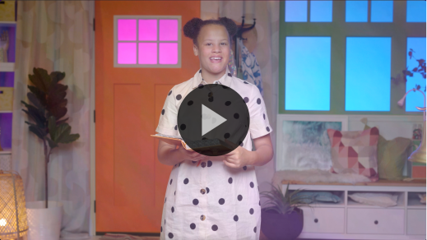

**Closing**

Let’s think about what we’ve done today. We practiced our Faith Verse about Jesus sending us. We sang songs to worship Jesus. We explored a really fun Bible story about listening to Jesus’ instructions. We discovered that He has important roles for us to play in teaching others about His truth.

• *Play the* ***Faith Fact Sound*** *video (bell ringing).*

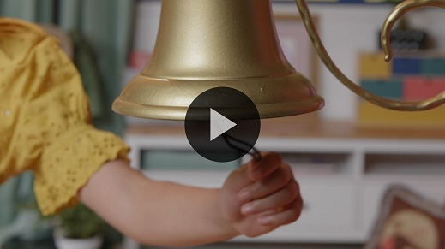

Oh good! That sound means it’s time to practice our Faith Fact one more time: **I have a role to play**.

• *Show the* ***Faith Fact Slide.***



Let’s shout it together. Ready? **I have a role to play.** Now, let’s show Jesus that we’re ready for our role by running in place *(demonstrate)* as fast as we can while we say the Faith Fact. Are you ready? **I have a role to play**.

**Dismissal to Small Groups**

Great job! Now you get to go have fun with your friends and leaders in your small groups.

• *Dismiss the kids by groups.*

|  |
| --- |
| ***Leader Tip:*** *This can be done by assigning color teams or by age groups. Note that some young preschoolers may not know their age. Using a colored sticker, jersey, or wristband will help separate the kids and help identify their small groups.* |

**Small Group**

**25 Minutes**

*See supplies and prep instructions at beginning of session or in each activity below.*

|  |
| --- |
| ***Leader Tip:*** *Small groups can alternate to each circle, or all groups can do each activity at the same time. If you choose to alternate, you will need at least one leader per circle.* |

**Circle 1**

**Group Connection**

**Listen Up!**

|  |
| --- |
| ***You Will Need***  *• Blindfold or bandana*  *• Something that makes noise (bell, set of keys, rubber duck, etc.)*  *No prep needed for this activity.* |

In our Bible story, Jesus sent His disciples out to tell people about God. Jesus said that some people would listen carefully to what the disciples had to say. He said that other people wouldn’t listen to them. Let’s play a game to see who in our group listens carefully.

• *Have kids sit in a circle about an arm’s length away from the next kid.*

Here’s how the game works. One kid will wear a blindfold and stand in the middle of the circle. We’ll pass around this bell *(hold up bell)* while trying to be very, very quiet. Then, I’ll point to someone who will ring the bell. When you’re in the middle and hear the bell, you’ll point in the direction of the sound. We’ll let you know if you’re right. Then, you can take off your blindfold and tell us the name of the friend who has the bell. The person who gets caught with the bell will go into the middle of the circle next. Are you ready?

• *Play as many rounds as time allows.*

You did a great job with that game! I love how each of you has a role to play and how you practiced listening carefully. Did you know Jesus lets us choose if we play our role in His story? Jesus wants to send us out. He wants us to tell others about God’s love. He lets us decide if we will go like He allowed His disciples to decide.

Wait, that reminds me of our Faith Verse. Do you think we can say it? *(Group response)* Great! Let’s try to say it and do the actions together.

• *Lead kids in saying Faith Verse with actions.*

[John 20:21](https://ref.ly/logosref/Bible.Jn20.21) (NLT)

[Jesus] said, “Peace be with you. As the Father has sent me, so I am sending you.”

**John** *(hands at waist, spread apart, palms up and out)*

**20:** *(hands together like a clap)*

**21** *(hands opened to “book”)*

**[Jesus] said**, *(sign language for Jesus—middle finger touches center of opposite hand palm)*

**“Peace be with you.** *(wrap arms around each other like giving yourself a hug)*

**As the Father has sent me**, *(point up both index fingers for Father)*

**so I am sending you.”** *(sign language for Jesus—middle finger touches center of opposite hand palm then both index fingers point away from body)*

Great job! Let’s practice listening carefully to the Faith Verse. First, the boys will say the verse and do the actions while the girls listen carefully.

• *Help the boys say the verse if needed.*

Now, it’s the girls’ turn to say the Faith Verse while the boys listen carefully.

• *Help the girls say the Faith Verse if needed.*

Remember that Jesus wants to send you to tell others about how much He loves them. He has a role for you to play in His mission.

**Circle 2**

**Activity Page Time**

**Faith Fact Fun**

|  |
| --- |
| ***You Will Need***  *•* ***Small Group Activity Page****, one per kid*  *• Crayons or markers*  *Getting Ready*  *• Print copies of the* ***Small Group Activity Page****, one per kid.* |

When Jesus sent out His disciples in our Bible story, they each had a decision to make. Would they listen and obey Jesus or would they choose to go home? Does anyone remember what choice they made? *(Group response)* Exactly! They chose to follow Jesus. They knew they had roles to play in God’s story just like you and I have. The best part is that each of our roles is as different as we are different. That’s what makes following Jesus so beautiful!

• *Hand out a copy of the* ***Small Group Activity Page*** *and crayons to each kid.*

On your ***Activity Page***, you’ll see our Faith Fact. I want you to color the letters exactly how you want to. You can use any color you want. You can stay inside the lines or color outside the lines. It’s completely up to you. Then, your Faith Fact will be unique just like you. When we’re finished, we’ll hold up our ***Activity Page*** and see how different they all are.

• *Allow time for kids to work on their pages.*

• *Have them hold completed pages up to show the group. Talk about how unique they all are like the kids.*

• *During the activity, interrupt and practice the Faith Fact:* **I have a role to play.**

• *Play the* ***Faith Fact Sound*** *video. Review the Faith Fact even if you can’t play the sound.*



Those ***Activity Pages*** look amazing! They are all so unique. When you take this page home, I want you to look at it every day and remember how special and unique you are. Remember that you have a role to play for Jesus!

**Circle 3**

**Feet-to-Floor Game Time**

**Pairs Relay**

|  |
| --- |
| ***You Will Need***  *• Floor safe tape (painter’s tape or masking tape)*  ***Getting Ready***  *• Make a path on the floor by taping lines that kids will walk along (zigzag, dashes for hopping, etc.).*  *• Make the path about 8–10 feet long.*  *• For larger groups, make more than one path for kids to follow to allow more than one group of kids to travel at a time.* |

Today, we learned that Jesus told a group of disciples to go and tell others about His plan. He didn’t tell everyone to go alone. Does anybody remember how many disciples He sent together? *(Allow responses.)* That’s right! He sent them in groups of two. So for our game, you’ll need a partner.

• *Be ready to participate with a kid if there is an odd number of kids in the group.*

First, I want to explain how this game will work. So click your ears and turn them on. *(Make motion as if twisting your ears to turn them on.)* Perfect! Now that everyone’s listening, I’ll teach you how to play. You and your partner will take turns leading each other down the path on the floor. *(Point to taped line.)*

The leader gets to decide how to move along the path. You can hop, crawl, go backwards, anything you want to do. The follower will do exactly the same thing as the leader. When you get to the other side, say our Faith Fact: **I have a role to play**. Then, you’ll switch roles and come back. Now, the second person gets to decide what actions to do. Once you make it back, the next set of partners will get a turn to go. Let’s play!

• *Help kids find a partner.*

• *Allow kids to each take a turn leading their partner down the path.*

You did such a good job of leading and following each other! You each had a role to play, and you were great! I want you to say our Faith Fact one more time. **I have a role to play.**

**Circle 4**

**Hands-On Learning**

**What’s My Role?**

|  |
| --- |
| **You Will Need**  • **Small Group Hands-On Learning Page**, one per group  **Getting Ready**  • Print the **Small Group Hands-On Learning Page**, one per group. |

What is a role or job you would love to do when you get older? *(Allow responses.)* There are lots of roles in our communities that are very important. Let’s look at some of them.

• *Show the* ***Small Group******Hands-On Learning Page*** *to the group.*

What roles do these people have? *(Allow responses.)* Every one of these roles takes special skills. Which roles require someone to be very brave? *(Allow responses.)* Which roles work inside most of the time? *(Allow responses.)* Which roles work outside most of the time? *(Allow responses.)* As I name each role, raise your hand if you know someone who does that job.

• *Read the roles and let kids respond.*

Like each of these people has a special role to play, you do, too. Each of you has talents. Those are the things you’re good at. Everyone has a role to play in God’s story, but your role isn’t exactly the same as your friends’ role. For example, you might be good at arts and crafts, but sound terrible when you sing. Someone else might not be good at arts and crafts, but they can sing beautifully. Let’s take turns telling the group one thing each of us are good at.

• *Allow the kids to take turns sharing with the group. This is also a great place to help to affirm kids’ talents.*

Even though we all have different things we’re good at, there is one thing Jesus wants all of us to be good at. Each of us has a role to play in helping other people know that Jesus loves them. No matter if you are a doctor, police officer, chef, construction worker, musician, or any other role, we can tell people about Jesus!

**Dismissal**

• *Play the* ***Faith Fact Sound*** *video (bell ringing).*



• *Show the* ***Faith Fact Slide.***



Friends, I’ve had so much fun learning with you today. It’s amazing that Jesus chose to use you and me to accomplish His great big plan. I love that each of us has a special role to play. Before you go home, I’d love to say our Faith Fact together one more time. Ready? **I have a role to play.** That’s right! I have a very important role to play, and you do, too! Great job learning from God’s Word with me today! I can’t wait to see you next time.

• *Send home the* ***Small Group Activity Page*** *with each kid.*

• *Remind parents that there are* ***Family Devotions*** *available on the app to do with their kid.*

• *Tell everyone the date and time for the next session.*